

CHMB31H3
Introduction to Inorganic Chemistry
Term test 1

October 9, 2019

Candidate Form
Before you begin your examination, please fill out this form and leave it at the side of your desk along with your student I.D. Please sign at time of collection.

Room # ________________________ Seat # (if assigned) _________

Name (please print):__________________________________________________________
Surname Given Names

Student Number:

Course: __CHMB31H3__ Instructor’s Name: __Alen Hadzovic________

Signature: ________________________________________________
(sign only at time form is collected)

CHMB31H3 – Introduction to Inorganic Chemistry
Term test 1

October 9, 2019

Answer all questions in full.
Value of each question is indicated. Total is 75 marks.
Aids Allowed: Appendix and Periodic Table of Elements (both provided at the back)
Non-programmable calculator

Please, read each question carefully and make sure you have indeed answered every part of each question!!!

Duration: 90 min (1.5 h)

GOOD LUCK!!

Student Name: ___________________

Student Number: _________________

- (6 marks) Astatine, one of the rarest elements in the Earth’s crust (it is estimated that our whole planet has between 1 and 10 g of this element) is in the same group of the periodic table as iodine.
  - One isotope of this element is formed during the alpha decay of ²²³Fr. Identify the astatine’s isotope formed and write balanced nuclear equation for this process.
  - Would you expect astatine to have more or less metallic character than iodine? Briefly explain your answer using the periodic trends.
  - Would you expect astatine to have higher or lower value of the first ionization potential than iodine? Briefly explain your answer using the periodic trends.
Answer:
a. The isotope is 219, ²¹⁹At
²²³Fr → ²¹⁹At + ⁴He (or α)
b.
More metallic character since it increases top to bottom in a group (or since At is below I in the periodic table
c.
Lower first ionization potential because ionization potential decreases from top to bottom in a group (or At is below I in the periodic table)

- (6 marks) Identify nuclides A, B and C formed during the fission of ²³⁵U nucleus:
²³⁵U + ¹n → ¹³¹Sn + A + 2 ¹n
²³⁵U + ¹n → ¹⁴²Ba + B + 2 ¹n
²³⁵U + ¹n → ¹⁴¹Cs + C + 2 ¹n
Answer:
A is:
¹⁰³Mo
B is:
⁹²Kr
C is:
⁹³Rb

- (8 marks) Starting from the following electronic configuration 1s² 2s²2p⁶ 3s²3p⁶3d¹⁰ 4s²4p¹ answer these questions:
a. Identify the element;
b. State to which group, period and block of the Periodic Table this element belongs;
c. Calculate the Z_{eff} for the 4p electron;
d. Based only on the electronic configuration, predict the most likely oxidation state/number for this element in its compounds.

Answer:
a.
Gallium (Ga)

b.
group: _ 13 __

period: _ 4 ___

block: _ p block___

c. Z_{eff} = Z – σ
(1s²)(2s² 2p⁶) (3s²3p⁶) (3d¹⁰) (4s²4p¹)
σ = 2 × 0.35 + 18 × 0.85 + 10 × 1.00 = 26
Z_{eff} = 31 – 26 = 5

d.
+3

- (2 marks) What is the difference between exergonic reaction and exothermic reaction?
Answer:
Exergonic reactions have Δ_{r}G < 0
Exothermic reactions have Δ_{r}H < 0

- (7 marks) Consider strontium chloride, SrCl₂.
  - Propose the most likely structure of SrCl₂ if r(Sr²⁺) = 126 pm and r(Cl–) = 181 pm;.
  - Hat are the coordination numbers of Sr²⁺ and Cl– in this structure?
  - Uranium dioxide, UO₂, has the same structure as SrCl₂. Without performing any calculations, predict which of the two (SrCl₂ or UO₂) has more stable lattice. Explain your reasoning.
Answer:
a. $ρ=\frac{126 pm}{181 pm}=0.696$ TiO₂ structure
b. Coordination number of Sr²⁺ is _ 6 _, coordination number for Cl– is __3_____.
c. More stable lattice has ___UO₂__, because:
The charges in UO₂ are higher than in SrCl₂ and lattice energy is proportional to the product $\left|z_{+}\right|\left|z_\right|$

- (12 marks) Sulfur tetrafluoride, SF₄, reacts with fluoride ion, F–, to produce SF₅–.
  - Identify Lewis acid and Lewis base in this reaction.
  - Draw a Lewis structure for SF₅–.
  - Write the equation for equilibrium constant for this reaction.
  - Using VSEPR theory, suggest the most plausible electron and molecular geometry (draw the structure!) for SF₅–. Comment on any possible deviation form ideal molecular geometry.
  - Suggest hybridization scheme for the central atom in this anion.
Answer:
a. Lewis acid is: ___ SF₄ ________, Lewis Base is ____F–______.

b. Equilibrium constant:
$K=\frac{\left[SF_{5}^{-}\right]}{\left[SF_{4}\right]×\left[F^{-}\right]}$
b. Lewis structure for SF₅–
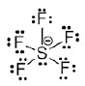
c.
Electron geometry is: __ octahedral_ Molecular geometry is: _square pyramid_

Structure:
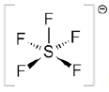
Comments?
The S – F bond angles are going to be less than 90° due to the repulsion with lone electron pair on S

d. Hybridization scheme:
sp³d²

- (10 marks) The following reduction potentials in acidic medium are given E(VO₂⁺, V³⁺) = +0.668 V and E(Zn²⁺, Zn)= –0.762 V.
  - Write down balanced reduction half-reaction for both redox couples.
  - Combine the two half-reactions so that the final redox reaction is balanced and spontaneous as written.
  - Using given reduction potentials, show that your reaction is indeed spontaneous as written (i.e. proceeds from left to right).
  - Calculate the missing potential in the Latimer diagram for vanadium at pH = 0:

Answer:
a.
Zn²⁺(aq) + 2e– → Zn(s)
VO₂⁺ + 2e– + 4H⁺(aq) → V³⁺(aq) + 2H₂O
b.
Zn(s) + VO₂⁺(aq) + 4H⁺(aq) → Zn²⁺(aq) + V³⁺(aq) + 2H₂O(l)
c.
as written: E = E_{red} – E_{ox} = E(VO₂⁺/V³⁺) – E(Zn²⁺/Zn) = +0.668V – (- 0.726V) = 1.394V
Since E > 0, Δ_{r}G < 0 and the reaction is spontaneous.
d.
$$E\left(V^{3+},V\right)=\frac{1×\left(-0.255V\right)+2×\left(-1.13 V\right)}{1+2}=-0.838V$$

- (3 marks) Underline (or circle) the stronger acid in the following pairs:

  - HClO₃ and HClO₂
  - [Sn(H₂O)₆]²⁺ and [Sn(H₂O)₆]⁴⁺
  - HCl and HI
- (8 marks) Draw a clear molecular orbital diagram for HO.

Answer:
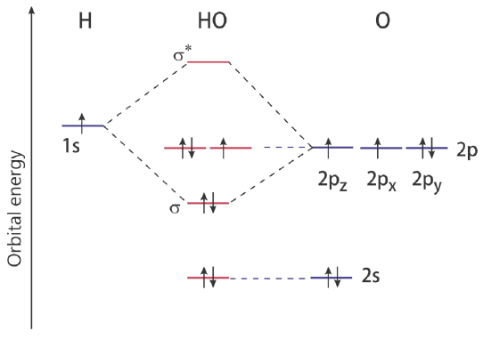

- (6 marks) Calculate partial charge (δ) on S in SF₄ and on B in BBr₃ if χ(S) = 2.58, χ(B) = 2.04, χ(Br) = 2.95 and χ(F) = 4.00.
Answer:
$$δ\left(S\right)=6-2-2×4\left(\frac{2.58}{2.58+4.00}\right)=0.86$$
$$δ\left(B\right)=3-0-2×3\left(\frac{2.04}{2.04+2.95}\right)=0.55$$

- (7 marks) Fill in the blanks to complete the definitions :

  - Isotopes have the same number of __protons___ (1 word) but different number of _neutrons___ (1 word) in their nuclei.
  - Atomic radii ___decrease_____ (1 word) from left to right along a period.
  - A positron is emitted during __beta plus_____ (2 words) decay.
  - Brønsted bases are proton __acceptors____. (1 word)
  - Reducing reagent is electron __donor______ . (1 word)

- END OF TEST –

APENDIX: Formulae, tables and plots
$I_{1}=\frac{1312.1\frac{kJ}{mol}×Z_{eff}^{2}}{n^{2}}$ $ΔH_{latt}=-\frac{1.07×{10}^{5}×ν×\left|z_{+}\right|\left|z_{-}\right|}{r_{+}+r_{-}}\frac{kJ×pm}{mol}$ $E^{0}=\frac{n_{A}E_{A}^{0}+n_{B}E_{B}^{0}+…}{n_{A}+n_{B}+…}$

$$δ_{}=\begin{matrix}Number of valence \\ electrons on X\end{matrix}-\begin{matrix}Number of lone \\ electrons on X\end{matrix}-2×\sum_{bonds}{\left(\frac{χ_{x}}{χ_{x}+χ_{y}}\right)}$$

Valence orbital energies
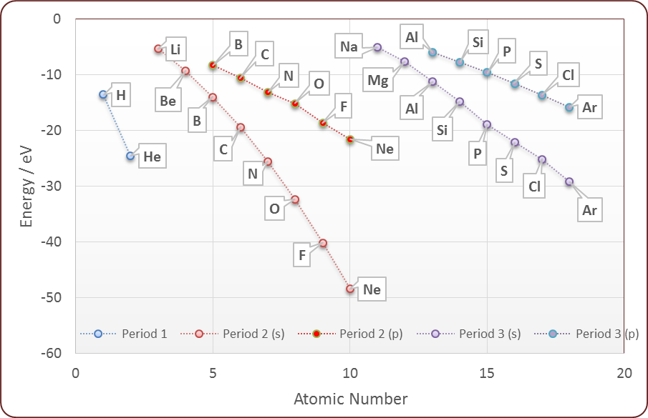

Hybridization schemes for electron geometries
Steric Number | Electron geometry | Hybridization Scheme(s)
2 | Linear | sp, pd, sd
3 | Trigonal planar | sp², p²d
4 | Tetrahedral | sp³, sd³
5 | Trigonal bipyramidal | sp³d
6 | Octahedral | sp³d²

Ratios for structure types:
Ratio range | AB type | AB₂ type
0.732 – 1 | CsCl | CaF₂
0.414 – 0.732 | NaCl | TiO₂
0.225 – 0.414 | ZnS

